Discovering Geometry with
Geometer’s Sketchpad:
The 9-Point Circle

Description: Geometer’s Sketchpad is a dynamic and easy to use software. This mini-course will demonstrate, through hands-on activities, various geometrical constructions. We will then combine these constructions to create a dynamic 9-point circle. This handout contains step-by-step directions.

Presented by
Natalie Hutchinson
Department of Mathematics & Statistics
Old Dominion University
nhutchin@odu.edu
757 683-3918

1 hour 15 minute Hands-On, Interactive Computer Mini-Course

The 14th Annual International Conference on Technology on Collegiate Mathematics
Baltimore, Maryland

3 November 2001

I would like to thank three of my Geometry students for reviewing the directions in this handout: Sabrena Fitgerald, Robert Gilkeson, and Susan Fernandez.

I would like to thank Mr. Mark Lesley and Dr. Michael Wagner for reviewing the proof.

Their input was invaluable.
On the Desktop, you should see the Geometer’s Sketchpad icon:

Double-click on the Geometer’s Sketchpad icon, and WAIT.

Setting up Preferences:
Select Display/Preferences in the menu bar (across the top of the screen).

In the dialogue box, click on Autoshow labels for points, it should be located in the upper left-hand corner. Click OK.

Now as we construct points, the labels A, B, C, … will be assigned to points consecutively. NOTE: Once a letter is used, Sketchpad will not automatically reuse that letter. You must begin a new sketch to begin using A, B, C, …

The Tool Bar:

Selection Arrow tools (Translate, Dilate, Rotate)


Point tool


Compass (Circle) tool


Straightedge tools (Segment, Ray, Line)


Label/Text tool


Object Information tool

On its most basic level, Sketchpad provides electronic versions of the tools Euclid used: a tool for creating points, a COLLAPSIBLE compass for constructing circles, and a straightedge for constructing segments, rays, or lines.

Let’s discover how these tools work. Notice that when the tool is selected it is highlighted in RED:


The Select Tool is used the most. If you wish to MOVE a point, a segment, a
circle, or any object, use the Select Tool . If you need to HIGHLIGHT a point, an
angle, a segment, a circle, or an object, use the Select Tool. You can tell if some
object is selected because it will be highlighted: a point will look like a bulls-eye, a
circle will have four tick marks, a line or ray or segment will have two tick marks.


The Point Tool creates points (labeled alphabetically). Let’s create some points.

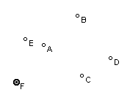

Select the Point Tool and click wherever you wish a point to be.


The Compass Tool or Circle Tool creates circles. Let’s create some circles.
In Sketchpad, circles are referred to by both their center point and the other
endpoint that determined the radius. So below you see ⬅CD and ⬅GH. If the
center were at B and the other radius endpoint was at A then we would use ⬅BA.
The first letter stated is the center of the circle. The second letter is the radius’
other endpoint.
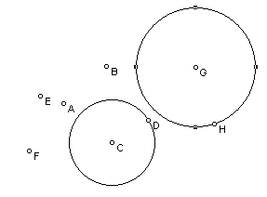

Select the Circle Tool and click-and-drag. The
first point will be the center, where you release the mouse will be the endpoint of the radius of the circle (Circle GH). To create Circle CD, place the Circle Tool over point C and drag the symbol to point D.


The Straightedge Tools or Segment Tool, Ray Tool, Line Tool,
create segments, rays, or lines. Let’s create some of these.
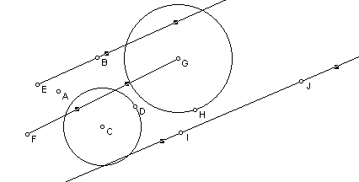
Create segment FG, ray EB, line IJ:
Select the Line Tool and click and drag (Line IJ).
Select the Ray Tool and click on point E and drag/release over point B (Ray EB).
Select the Segment Tool and click on point F and drag/release over point G (Segment FG).

There are two ways to “construct” in Sketchpad. You may use the freehand tools (point, circle, straightedge tools) OR you may use pull-down menu features. We will experiment with both.

Determining the midpoints of line segments:
Select File/New Sketch. We will begin again.

Select the Segment Tool.

We are going to construct line segment AB. Position the cursor in the blank screen and left-click and drag. Release the left mouse button and you should have line segment AB. The labels for the endpoints should appear.

We wish to determine the midpoint of this line segment. We will learn two methods:

The first method: Using the freehand tools, we will find the midpoint by construction.

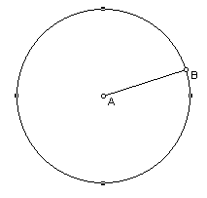
1. Change to the Circle Tool 
Place the cursor over point A and click-and-drag the cursor until the circle symbol is over point B. Release the mouse when the circle symbol is immediately over B. This is known as ⬅AB.

2. Choose the Select Tool  and test your construction. Does your circle have line segment AB as its radius always? If not, redo the circle. (Edit/Undo Draw Circle)

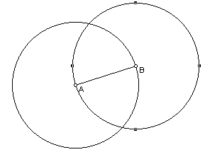
3. Change back to the Circle Tool . Now place the cursor over point B and click-and-drag the cursor to point A. Release the mouse over point A. This is known as ⬅BA.

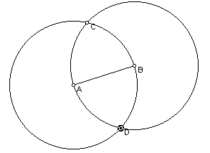
4. Choose the Point Tool  and place points C and D at the intersections of the two circles.

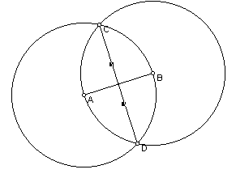
5. Choose the Line Segment Tool  and construct line segment CD.

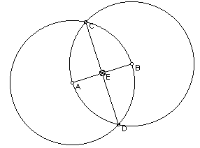

6. Choose the Point Tool and place point E at the intersection of segment AB and segment CD.

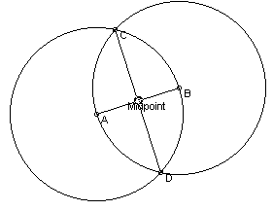

7. Using the Select Tool, double-click on the label E. Change its name to Midpoint, then click on OK. Test your sketch by selecting and dragging points and segments. If the constructions was done successfully, your construction will not fall apart and the Midpoint will remain the midpoint of segment AB.
The second method: Using the pull-down menus, we will construct the midpoint.
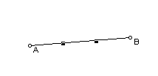
1. File/New Sketch. We will begin again.

2. Select the Segment Tool and create segment AB again.

3. Notice segment AB is highlighted.

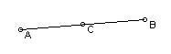
4. Up in the menu-bar, select Construct/Point at Midpoint.
This creates point C.

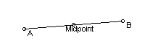
5. Using the Select Tool, double-click on the label C. Change
its name to Midpoint.

Test your sketch by manipulating it.

Determining the perpendicular to a line from a point not on the line:
Select File/New Sketch. We will begin again. To speed up the process, we will take advantage of the pull-down menus.

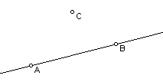

1. Create line AB (use the Line Tool).
Create point C not on line AB (use the Point Tool).

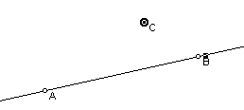

2. Using the Select Tool, and the shift key, select BOTH
point C and line AB. (Make sure both items are
highlighted)

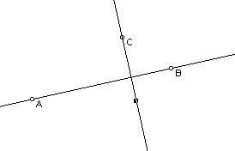
D
3. From the menu bar, select Construct/Perpendicular
Line. A perpendicular line should be created passing
through point C and intersecting line AB.
4. Manipulate your sketch to make sure you have a
perpendicular line.
5. To create the point D at the intersection, select line AB
and the perpendicular line. Then Construct/Point at
Intersection.

Determining the three altitudes of a triangle and labeling the “foot” of each altitude:
Select File/New Sketch. We will begin again. To speed up the process, we will take advantage of the pull-down menus.
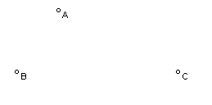

1. Using the Point Tool, construct three noncollinear points A, B, and C.

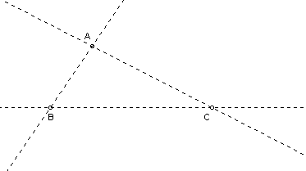
2. Select the Line Tool, then from the menu bar select Display/Line Style/Dashed. It is important that you choose the LINE TOOL, not the segment or ray tool. Construct “dashed” lines AB, AC, and BC.
Example: place the cursor over point A and click-and-drag to point B, release cursor over point. This creates dotted line AB.

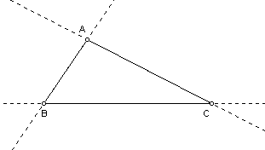
3. Click off so NOTHING is highlighted.
Select Display/Line Style/Thin. Using the Segment Tool, construct “solid” segments AB, AC, and BC on top of the dotted lines.
Example: place the cursor over point A and click-and-drag to point B, release cursor over point. This creates solid line segment AB.
REPEAT to create segments AC and BC.

We now wish to construct the three altitudes of the triangle:

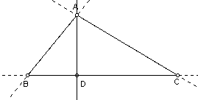
First Altitude: Select point A and segment or line BC (it doesn’t matter which one you select). Then select Construct/Perpendicular Line from the menu bar. Select the perpendicular line and LINE BC. Then select Construct/Point at Intersection from the menu bar. Where the perpendicular intersects line BC, the label is D. Note, you must choose the line, not the line segment when you construct point D. Manipulate the triangle to see that point D travels along line BC. Point D is called the “foot” of this altitude.
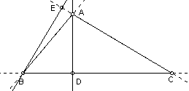
Second Altitude: Select point B and segment or line AC. Then select Construct/Perpendicular Line from the menu bar. Select the perpendicular line and LINE AC, then select Construct/Point at Intersection. Where the perpendicular intersects line AC, the label E. Manipulate the triangle to see that point E travels along line AC. Point E is called the “foot” of this altitude.

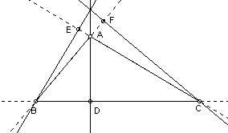
Third Altitude: Select point C and segment or line AB. Then select Construct/Perpendicular Line from the menu bar. Select the perpendicular line and LINE AB, then select Construct/Point at Intersection. Where the perpendicular intersects line AB, the label is F. Manipulate the triangle to see that point F travels along line AB. Point F is called the “foot” of this altitude.

Points D, E, and F are each a “foot” of an altitude. We have found three of the nine points we need for our 9-point circle. More about that later.

Note: The three altitudes are concurrent (three or more lines intersect at one point). The point of concurrency is called the Orthocenter of the triangle.

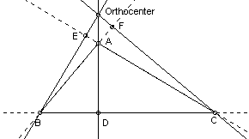

We wish to label the Orthocenter in our construction. First we must create the point of intersection. Geometer’s Sketchpad will only let an intersection point be constructed if only two lines are selected (not three). So select two of the three altitudes simultaneously. Then select Construct/Point at Intersection. This will create point G. If you wish, you may rename point G as the Orthocenter.

Manipulate the sketch by dragging one of the vertices of triangle ABC.

Observe the feet (D, E, and F).

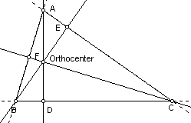
You should notice that the feet:

may be ON the triangle (acute triangle),

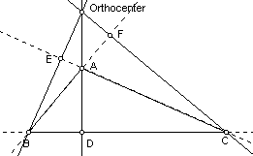

may have two feet outside the triangle on the side extensions (obtuse triangle),

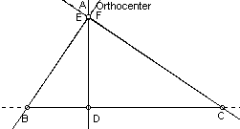

may have two feet coincide at one vertex of the triangle (right triangle).

Also observe the Orthocenter (G).
You should notice that the Orthocenter:
may be inside the triangle (acute triangle),
may be outside the triangle (obtuse triangle),
may be on the triangle at the right angle vertex (right triangle).

Determining the Euler Points of a triangle:

We will continue to use the same triangle ABC that has feet D, E, and F and the Orthocenter labeled.
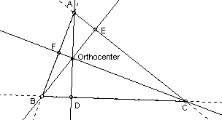
Now we will determine the Euler Points of the triangle.

Manipulate your triangle ABC into an acute triangle (simply select and move one of the vertices A, B, or C). The Orthocenter should be INSIDE the triangle and the “feet” of the altitudes, D, E, and F, should be ON the triangle.

The Euler Points are the midpoints of the line segments joining the Orthocenter to the vertices of triangle ABC. First, we must CONSTRUCT these line segments.

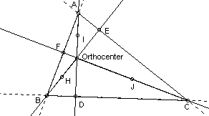
Select Segment Tool and construct segment BOrthocenter or segment BG. While it is highlighted, choose Construct/Point at Midpoint. This should create point H.

Select Segment Tool and construct segment AOrthocenter or segment AG. While it is highlighted, choose Construct/Point at Midpoint. This should create point I.

Select Segment Tool and construct segment COrthocenter or segment CG. While it is highlighted, choose Construct/Point at Midpoint. This should create point J.
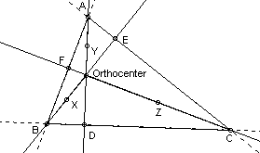

We wish to relabel points H, I, and J as X, Y, and Z, respectively. Double-click on the label, change the label in the dialogue box that appears.

Manipulate triangle ABC to make it obtuse. Observe how X, Y, and Z move (relocate).

Manipulate triangle ABC to make it appear a right triangle. Observe how X, Y, and Z mover (relocate).

Manipulate triangle ABC into an acute triangle.
Points X, Y, and Z are the Euler Points of triangle ABC. We have found three more of the nine points we need for our 9-point circle!
NOW for the 9-Point Circle:

The most recent triangle ABC has 3 “feet” of the altitudes (D, E, F)
and 3 Euler points (X, Y, Z).

Now we need the other three points. These are the three midpoints of the SIDES of triangle ABC.
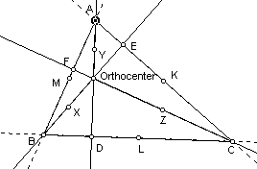

Select SEGMENTS AB, BC, and AC simultaneously (make sure you select ONLY the segments, not the dotted lines). Then select Construct/Point at Midpoint. They should be labeled K, L, and M.

Points K, L, and M are the midpoints of the sides of triangle ABC. We have constructed the last three points we needed.

Consider only the following nine points: the “feet” (D, E, and F), the Euler points (X, Y, and Z), and the midpoints of the sides (K, L, and M). It can be proven that these nine points lie on the SAME circle! This circle is called the 9-Point Circle.

How do we construct this circle? We need a center and a radius.

Determining the center of the 9-Point Circle:
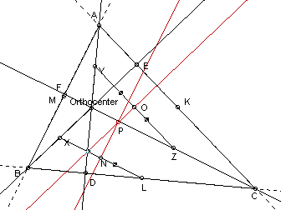
Select any two of these 9 points, such as L and X.
Construct a segment joining these two points (segment LX).

Construct the perpendicular bisector of segment LX. (With Segment LX selected, select Construct/Point at Midpoint. The midpoint should be point N. Select both point N and Segment LX, then Construct/Perpendicular Line)

Repeat this process with ANOTHER two of these 9 points, such as Y and Z.

Where the two perpendicular bisectors intersect is the CENTER of the 9-Point Circle. It should be labeled point P.

You may hide segments XL and YZ by selecting them and choosing Display/Hide Segments.
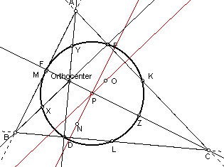
Any segment from point P (the center of the 9-Point Circle) to one of the 9 points is the radius.

Any circle constructed with center at point P and radius to any one of the 9 points will pass through all 9 points.

Try it.
Select the Circle Tool and use P as the center of the circle, click and drag to one of the 9 points (such as K).

This is the 9-Point Circle.

Manipulate your triangle and observe how the circle moves.

When is the circle inscribed in the triangle? What kind of triangle is it when it is inscribed?

When is the circle extending outside of the triangle? What kind of triangle is it when it is extending outside?

Theorem: The three midpoints of the sides of a triangle, the three feet of the altitudes of a triangle, and the three Euler points of a triangle all lie on a circle. (The 9-Point Circle)

Proof:
Given ΔABC.
Let M, K, L be the midpoints of sides $\overline{\text{AB}}, \overline{\text{BC}}, \text{and} \overline{\text{AC}}$, respectively. Let D, E, F be the feet of the altitudes (the points of intersection of the altitude with the opposite sides).
The altitudes ($\overline{\text{BE}}, \overline{\text{AD}}, \text{and} \overline{\text{CF}}$) are concurrent (when three or more lines intersect at one point) at the Orthocenter or H. (See Theorem 1)

Consider the segments from the Orthocenter (H) to each vertex of the triangle: $\overline{\text{HB}}, \overline{\text{HA}}, \text{and} \overline{\text{HC}}$. Let X, Y, Z be the midpoints of these line segments, respectively. X, Y, and Z are called Euler points.

[Note: “Euler first proved in 1765 that the feet of the altitudes (D, E, F) and midpoints of the sides (K, L, M) lie on a circle, but he missed the Euler points. Over 50 years later, C. J. Brianchon and J. V. Poncelet – without knowing of Euler’s Theorem – proved that all nine points lie on a circle.” From Berele and Goldman’s Geometry: Theorems and Constructions, p. 124]
Consider quadrilateral MYZK in ΔABC:
M is the midpoint of $\overline{\text{AB}}$, Y is the midpoint of $\overline{\text{AH}}$. In ΔABH we know $\overline{\text{MY}} || \overline{\text{BH}}$ and MY = ½BH. (See Theorem 2)
K is the midpoint of $\overline{\text{BC}}$, Z is the midpoint of $\overline{\text{CH}}$. In ΔCBH we know $\overline{\text{KZ}} || \overline{\text{BH}}$ and KZ = ½BH. (See Theorem 2)
So, MY = KZ or $\overline{\text{MY}} ≃ \overline{\text{KZ}}$ and $\overline{\text{MY}} || \overline{\text{KZ}}$. (See Theorem 3)
Since $\overline{\text{MY}} ≃ \overline{\text{KZ}}$ and $\overline{\text{MY}} || \overline{\text{KZ}}$ we know quadrilateral MYZK is a parallelogram. (See Theorem 4)

We know $\overline{\text{BE}} ⊥ \overline{\text{AC}}$ by definition of an altitude. Also $\overline{\text{MK}} || \overline{\text{AC}}$since M and K are midpoints of sides of ΔABC. So $\overline{\text{BE}} ⊥ \overline{\text{MK}}$. Recall $\overline{\text{MY}} || \overline{\text{KZ}} || \overline{\text{BH}} \text{and} || \overline{\text{BE}}$. So $\overline{\text{MK}} ⊥ \overline{\text{MY}}$ and $\overline{\text{MK}} ⊥ \overline{\text{KZ}}$. (See Theorem 5) Then parallelogram MYZK is also a rectangle, definition of a rectangle.
Consider the diagonals of rectangle MYZK, $\overline{\text{MZ}} \text{and} \overline{\text{YK}}$.
We label P the intersection of diagonals $\overline{\text{MZ}} \text{and} \overline{\text{YK}}$.
We know the diagonals of a rectangle are congruent and bisect each other. (See Theorem 6)
So $\overline{\text{MP}} ≃ \overline{\text{YP}} ≃ \overline{\text{KP}} ≃ \overline{\text{ZP}}$. Therefore, a circle centered at P can be constructed through M, Y, Z, and K, with $\overline{\text{MP}}, \overline{\text{YP}}, \overline{\text{KP},} \text{and} \overline{\text{ZP}}$as radii of the circle centered at P. (Definition of a circle) Or said another way, $\overline{\text{MZ}}$is a diameter of a circle containing points Y and K.

You may repeat this argument for quadrilateral MLZX in ΔABC, and conclude that $\overline{\text{MZ}}$is a diameter of a circle containing points X and L.

Notice $\overline{\text{MZ}}$is a diameter for a circle containing points Y and K AND for a circle containing points X and L. We conclude that ONE circle passes through points K, L, M and X, Y, Z. Also, $\overline{\text{LX}}, \overline{\text{KY}}, \text{and} \overline{\text{MZ}}$ are all diameters of the same circle.

Recall D, E, and F are feet of altitudes. We know the following: ∠XEL is a right angle whose sides intersect the endpoints of diameter $\overline{\text{LX}}$which together form right ΔXEL.

∠YDK is a right angle whose sides intersect the endpoints of diameter $\overline{\text{KY}}$which together form right ΔYDK, and ∠ZFM is a right angle whose sides intersect the endpoints of diameter $\overline{\text{MZ}}$which together form right ΔZFM. Therefore D, E, and F are on the circle with diameter $\overline{\text{LX}}, \overline{\text{KY}}, \text{and} \overline{\text{MZ}}$, respectively. (See Theorem 7) But $\overline{\text{LX}}, \overline{\text{KY}}, \text{and} \overline{\text{MZ}}$are already diameters of the same circle (earlier result). So all 9 points lie on the same circle.

Q.E.D.

Referenced Theorems:

Theorem 1: The altitudes of a triangle are concurrent. The point of concurrency is called the orthocenter.

Theorem 2: A line segment that joins the midpoints of two sides of a triangle is parallel to the third side and half as long.

Theorem 3: If two lines are parallel to a third line, then the two lines are parallel to each other.

Theorem 4: If a pair of sides of a quadrilateral are both parallel and congruent, then the quadrilateral is a parallelogram.

Theorem 5: If one line of a set of parallel lines is perpendicular to another line then all the parallel lines are
perpendicular to this other line.

Theorem 6: The diagonals of a rectangle are congruent and bisect each other.

Theorem 7: If a right triangle has its hypotenuse as the diameter of a circle, then its right angle vertex is on the circle.

Proof by Natalie Hutchinson
Mathematics & Statistics Department
Old Dominion University
nhutchin@odu.edu, 757 683-3918

