Department of Mathematics and Statistics
Old Dominion University

presents

Professor C. R. Rao

Pennsylvania State University

"Statistics: The science, technology and art of creating new knowledge"

Friday, April 16, 2004
Time: 2 – 3 PM, Location: Constant 1005
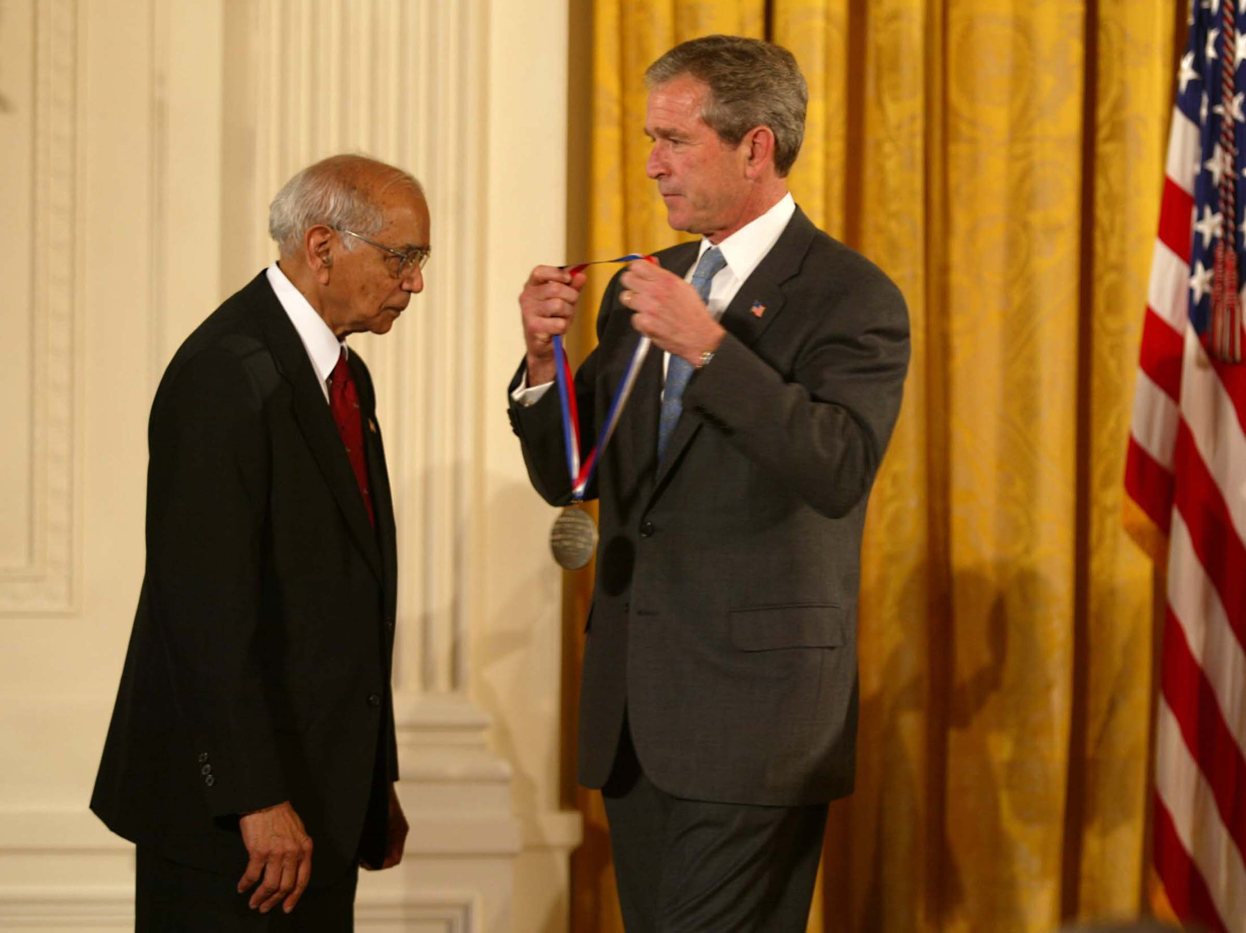
Short Biography of Professor C. R. Rao
Professor C.R. Rao is among the world leaders in statistical science over the last six decades. His research, scholarship and professional services have had a profound influence in theory and applications of statistics. Technical terms such as, Cramer-Rao inequality, Rao-Blackwellization, Rao’s Score Test, Fisher-Rao Theorem, Rao’s distance, and orthogonal arrays (described by Forbes Magazine as “new manthra” for industries) appear in all standard books on statistics. Two of his papers appear in Breakthroughs in Statistics in the last century. C.R. Rao is the author of 14 books and about 350 research papers. Three of his books have been translated into several European and Chinese and Japanese languages.
Professor Rao has received 29 Honorary Doctoral degrees from universities in 17 countries around the world. He held several important positions, as the Director of the Indian Statistical Institute, National Professor in India, University Professor at the University of Pittsburgh and Eberly Professor of Statistics and Director of the Center for Multivariate Analysis at the Pennsylvania State University.
Professor Rao has won several medals and awards: Gold Medal of Calcutta University, Wilks Medal of the American Statistical Association, Guy Medal in Silver of the Royal Statistical Society, Bhatnagar award of the Council of Scientific and Industrial Research in India. At the Berlin conference of the International Statistical Institute held in 2003, Professor Rao received the prestigious International Mahalanobis Prize for lifetime achievement in statistics and the promotion of best statistical practice.
Professor Rao holds membership in prestigious societies. He has been elected to the National Academy of Sciences, USA, American Academy of Arts and Science, Royal Society, UK, Indian National Science Academy, Lithuanian Academy of Sciences and Third World Academy of Sciences. He was made an Honorary Member of the International Statistical Institute, International Biometric Society, Royal Statistical Society, Finnish Statistical Society, Portuguese Statistical Society, Institute of Combinatorics and Applications and World Innovation Foundation, and Honorary Life Fellow of King’s College, Cambridge, UK.
Recently Professor Rao was honored by the President of the USA with the prestigious National Medal of Science “as a prophet of new age” with the citation, “for his pioneering contributions to the foundations of statistical theory and multivariate statistical methodology and their applications, enriching the physical biological, mathematical, economic and engineering sciences.”

